Deliverable 1 Details

By Saturday before class you must submit a detailed plan of action for your project.

In this plan, you will include:

1. An overview of the intended application and WHY you feel it’s valuable.
   1. The project is a web application for a business in the landscape industry to be able to have access to a tried and true bidding system to price, sell, and secure new projects.
2. A set of DETAILED screen-by-screen design layouts with annotations describing all UI/UX components and all data relevant to the screen.
3. List of group members
   1. Stefan Beaulieu
4. A breakdown of roles by group member.
   1. Design, structure, front end, backend, implementation all completed by Stefan Beaulieu
5. A schedule for completion of various tasks.
   1. March 4-7 – Tweek final layouts via Sketch and complete home page
   2. March 8-11 – Enhancement, Construction, and Maintenance Division Pages set with layouts complete. Have fully functional home page.
   3. March 12-14 – Complete Subpages functionality. Start to debug flaws and tweek possible UI flaws with adding items.
   4. March 15-18 – Complete functionality of site and pass to others for testing.
   5. March 19- April 4 – Completely Debug Site. Complete presentation.
   6. April 5 – Demo Day
6. A screenshot of your Jira, Trello, or Project Management Board that shows breakdown of tasks – assigned to group members with a schedule.

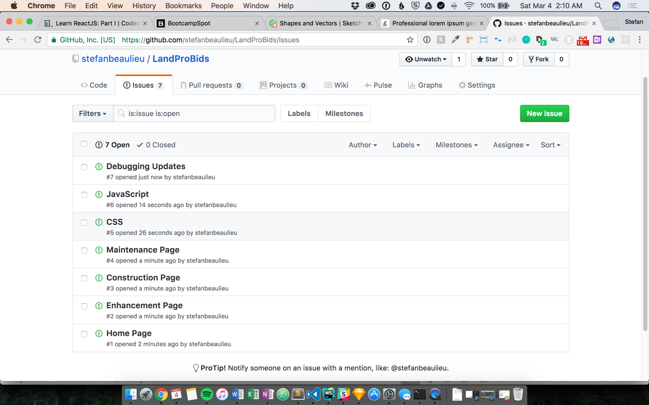

Here is an article describing a bunch of wireframe tools. Of these, I’ve used Balsamiq.  
<https://dcrazed.com/best-free-wireframe-tools/>